MODEL ENGINEERING COLLEGE, THRIKKAKARA

DEPARTMENT OF COMPUTER ENGINEERING



RECORD OF PRACTICAL WORKS

OOP CST205

CLASS: CS 3 B (2019 Ad.)

Name of Student: ADITHYA A

Roll No: 03

EXP No.: 01

Ternary Operator

AIM

Program to demonstrate the ternary operator in java.

PROGRAM

class Main {

public static void main(String args[ ]) {

int x=5,y=4;

int z = x>=y?x:y;

System.out.println("greater number is "+z);

}

}

OUTPUT

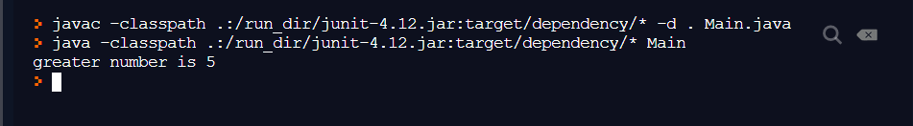

EXP No.: 02

If else ladder

AIM

Demonstrate a Java program that uses if else ladder.

PROGRAM

class Main {

public static void main(String[] args) {

int marks=85;

if(marks<50){

System.out.println("fail");

}

else if(marks>=50 && marks<60){

System.out.println("your grade is D ");

}

else if(marks>=60 && marks<70){

System.out.println("your grade is C");

}

else if(marks>=70 && marks<80){

System.out.println("your grade is B");

}

else if(marks>=80 && marks<90){

System.out.println("your grade is A");

}else if(marks>=90 && marks<100){

System.out.println("your grade is A+");

}

}

}

OUTPUT

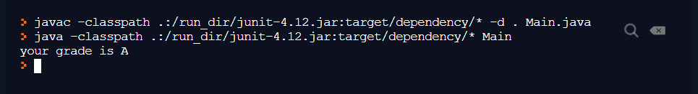

EXP No.: 03

Switch operator

AIM

Program to Illustrate the use of ‘switch’ in Java

PROGRAM

class Main {

public static void main(String[] args) {

int day = 4;

switch (day) {

case 1:

System.out.println("Monday");

break;

case 2:

System.out.println("Tuesday");

break;

case 3:

System.out.println("Wednesday");

break;

case 4:

System.out.println("Thursday");

break;

case 5:

System.out.println("Friday");

break;

case 6:

System.out.println("Saturday");

break;

case 7:

System.out.println("Sunday");

break;

}

}

}

OUTPUT

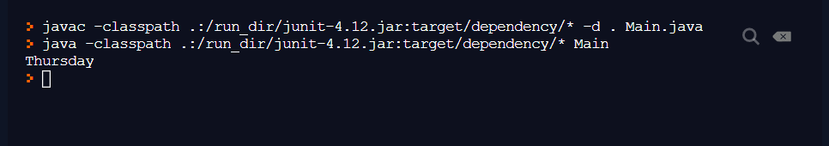

EXP No.: 04

Matrix transpose

AIM

JAVA program to find the transpose of a matrix

PROGRAM

class main {

public static void main(String[] args) {

int r = 2, c = 3;

int[][] matrix = { {1, 2, 3}, {4, 5, 6} };

display(matrix);

int[][] transpose = new int[c][r];

for(int i = 0; i < r; i++) {

for (int j = 0; j < c; j++) {

transpose[j][i] = matrix[i][j];

}

}

display(transpose);

}

public static void display(int[][] matrix) {

System.out.println("The matrix is: ");

for(int[] r : matrix) {

for (int c : r) {

System.out.print(c + " ");

}

System.out.println();

}

}

}OUTPUT

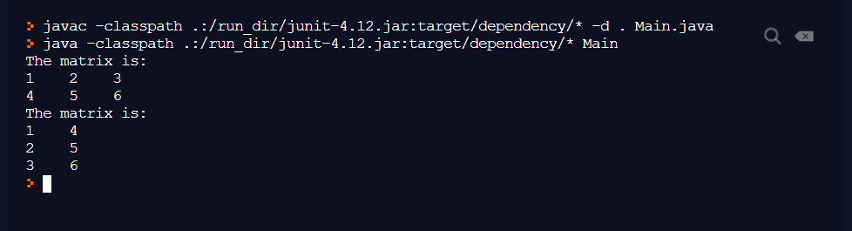

EXP No.: 05

Sum of Matrix

AIM

JAVA program to find the sum of two matrices

PROGRAM

class Main {

public static void main(String[] args) {

int r = 2, c = 3;

int[][] firstMatrix = { {2, 3, 4}, {5, 2, 3} };

int[][] secondMatrix = { {-4, 5, 3}, {5, 6, 3} };

display(firstMatrix);

display(secondMatrix);

int[][] sum = new int[r][c];

for(int i = 0; i < r; i++) {

for (int j = 0; j < c; j++) {

sum[i][j] = firstMatrix[i][j] + secondMatrix[i][j];

}

}

display(sum);

}

public static void display(int[][] matrix) {

System.out.println("The matrix is: ");

for(int[] r : matrix) {

for (int c : r) {

System.out.print(c + " ");

}

System.out.println();

}

}

}OUTPUT

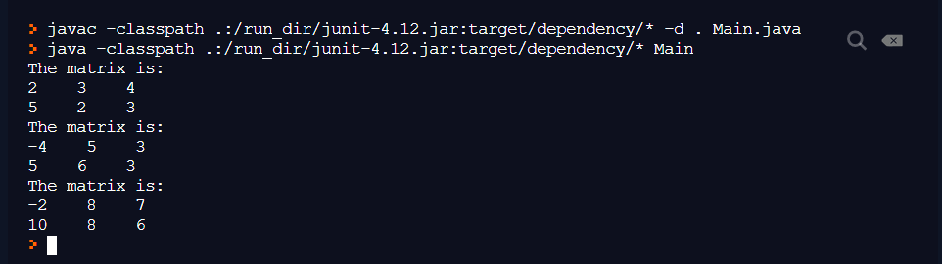

EXP No.: 06

Product of matrix

AIM

JAVA program to find the product of two matrices

PROGRAM

class Main {

public static void main(String[] args) {

int r = 2, c = 3;

int[][] firstMatrix = { {2, 3, 4}, {5, 2, 3} };

int[][] secondMatrix = { {-4, 5, 3}, {5, 6, 3} };

display(firstMatrix);

display(secondMatrix);

int[][] product = new int[r][c];

for(int i = 0; i < r; i++) {

for (int j = 0; j < c; j++) {

product[i][j] = firstMatrix[i][j] \* secondMatrix[i][j];

}

}

display(product);

}

public static void display(int[][] matrix) {

System.out.println("The matrix is: ");

for(int[] r : matrix) {

for (int c : r) {

System.out.print(c + " ");

}

System.out.println();

}

}

}

OUTPUT

